How to access Teams
Type in https://www.office.com you will be presented with the office homepage as shown below, then click sign in.
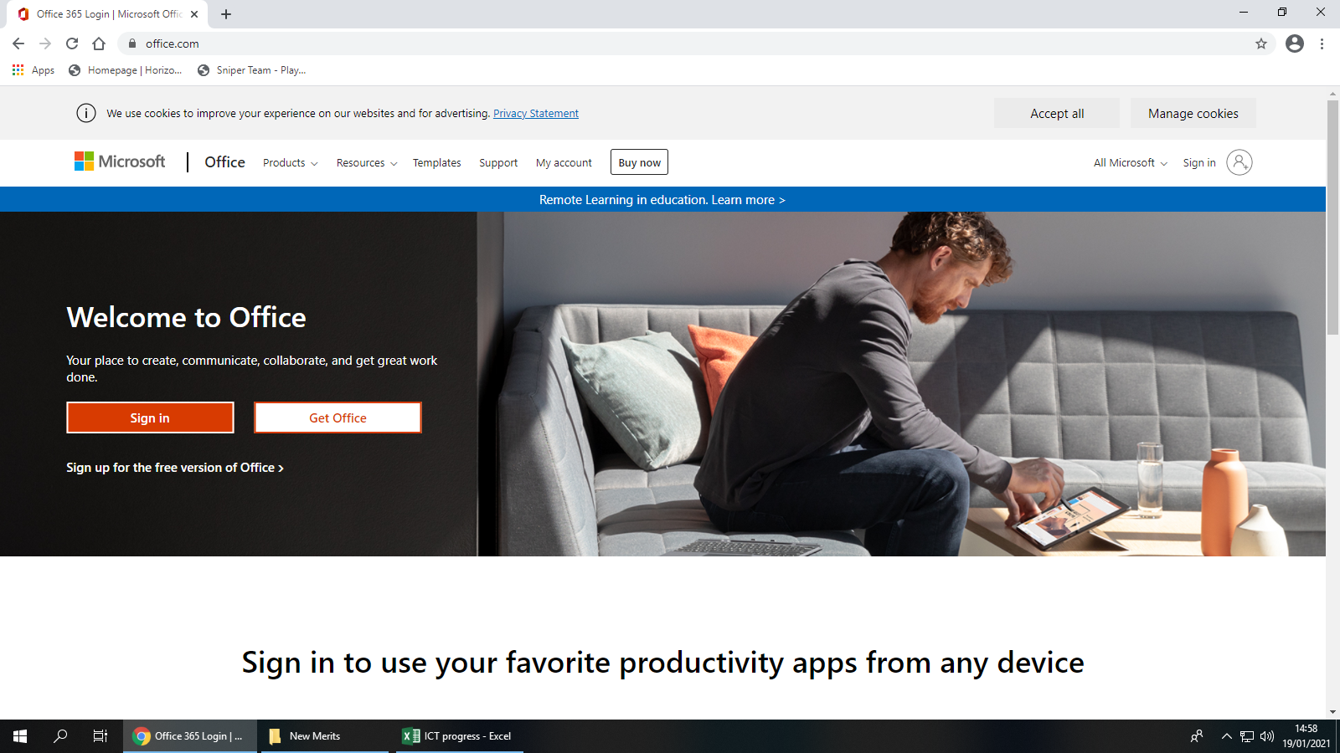

To sign in, students use their first name, followed by a full stop, then their surname. @ha.horizonstrust.org.uk

See example below for Joe Bloggs:

joe.bloggs@ha.horizonstrust.org.uk

The student password is the same as they use to login to the computers at school. If a student has forgotten their password, please call Hollis Academy and ask to speak to Mr Simpson, I can issue a new password over the phone.

Once logged in, students should click on the 9 black little squares in the top left hand corner, see screenshot below.

Then click on Teams, see below.

You will then be presented with this screen, I would recommend to ‘Use the web app instead’ option. Please see the diagram below:

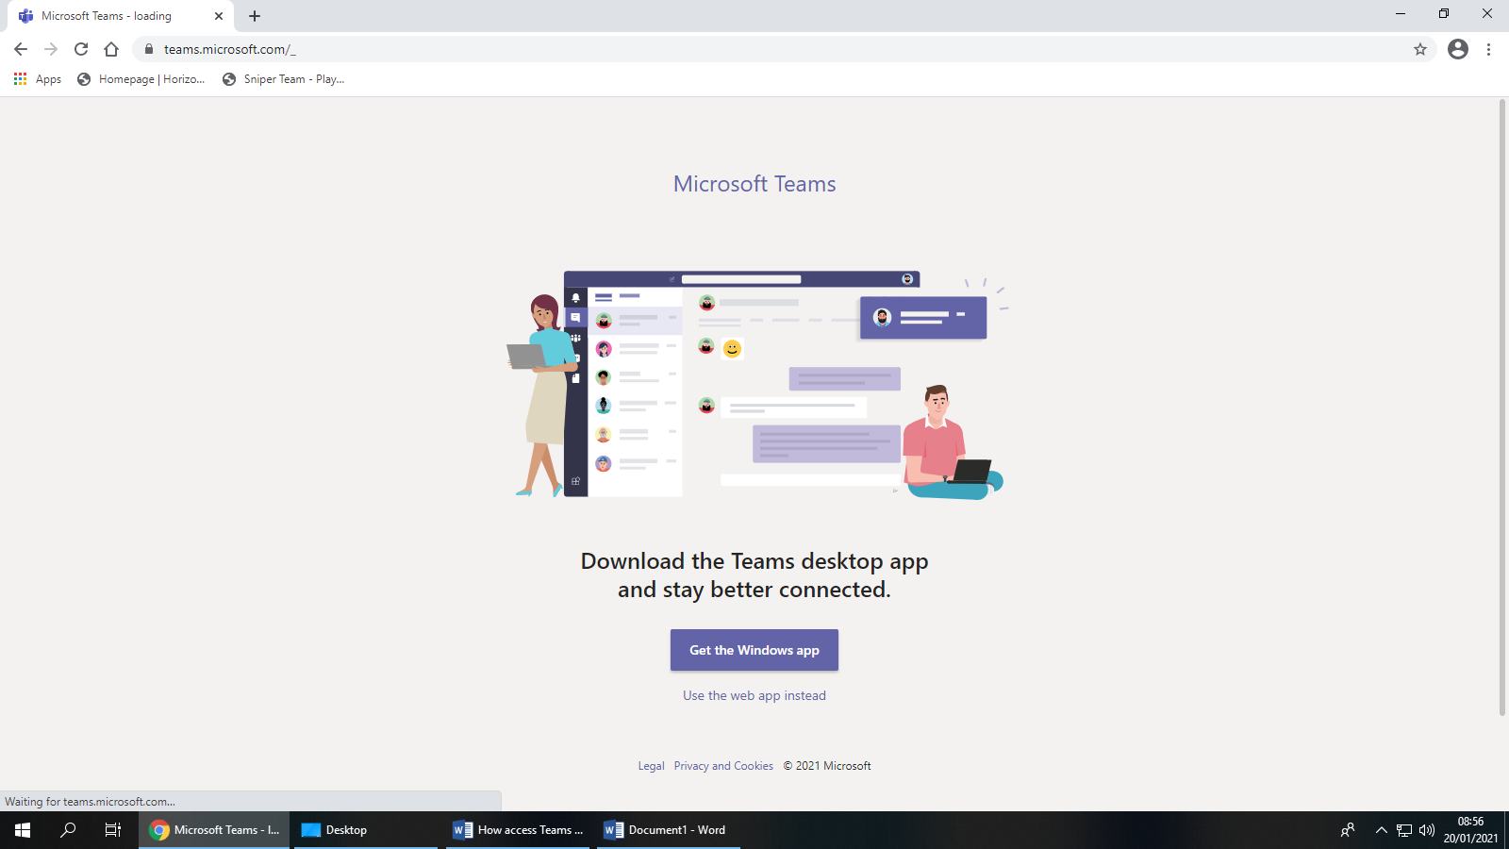

You will then be presented with the Teams homepage. Under the column, ‘Teams’ is where students can see their subjects.
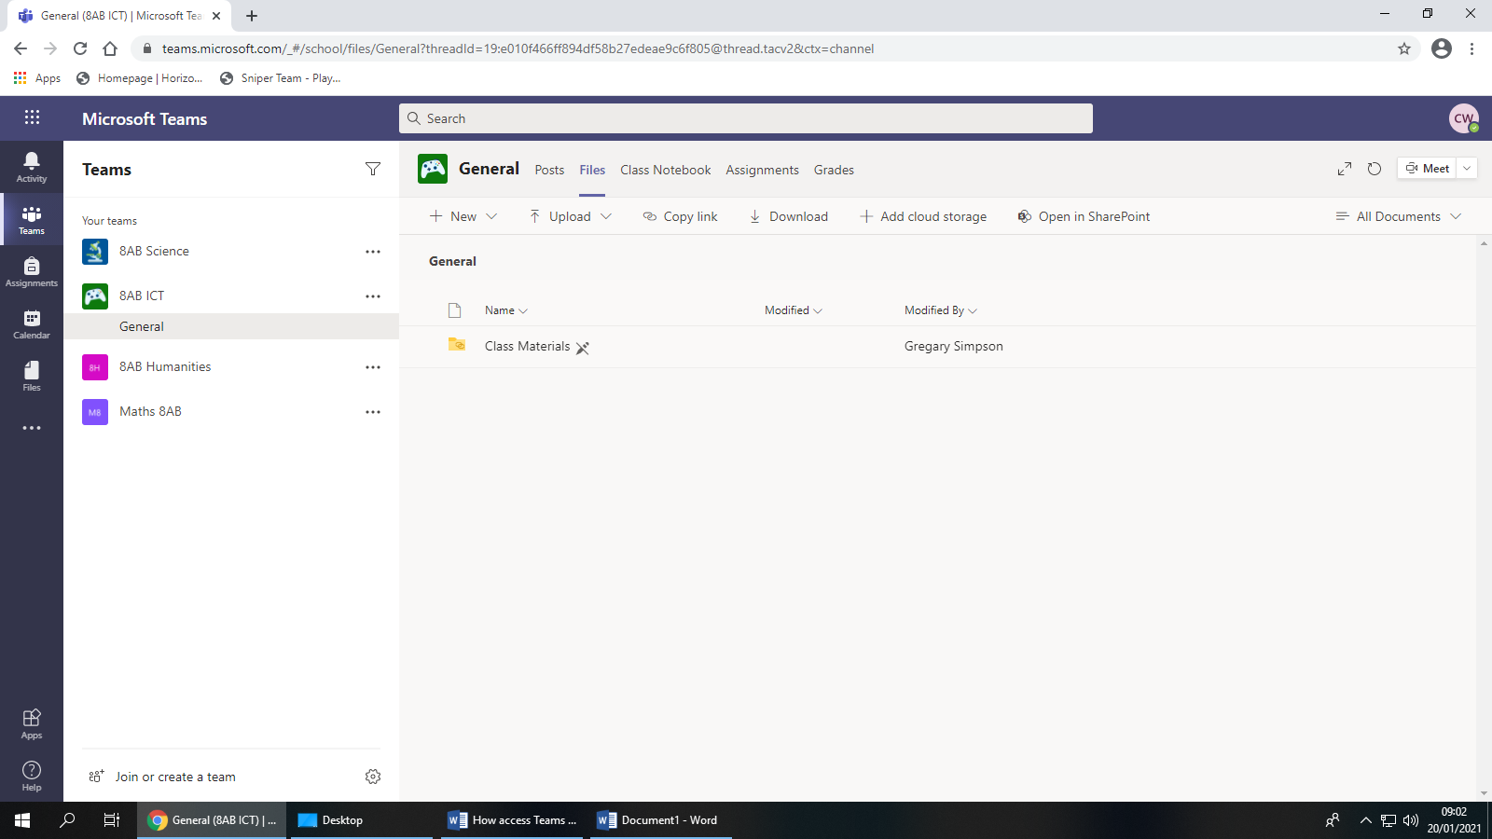

Once you have clicked on a subject, you will then need to click on ‘files’ to access the work.

Then the lessons can be accessed below.

Once a lesson is selected, students can start a conversation with their teacher, by selecting the conversation button. See below:

