Summer Term Week 2- 27.4.2020
Key Words
Sun Pluto
The Moon Neptune
Mercury Saturn
Venus Mars
Earth Uranus
Jupiter
Task 1-
Draw or design a model of the solar system-

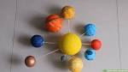
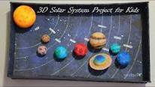

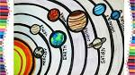
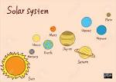

Can you see Venus in the sky at night? It looks like a bright star in an eastern direction!

Task 2-
Solar Eclipse vs Lunar Eclipse-
Watch this video about a the difference between a lunar eclipse and a solar eclipse (YouTube- What is an eclipse? Lunar and Solar eclipses explained)
https://www.youtube.com/watch?v=SczY9FtfhNw
Draw a diagram to show the difference between the two.

