Help save the Earth in three easy steps

1. Eat less meat
"salad" by Witches Falls Cotages is licensed under CC BY 2.0

Did you know that the meat industry is responsible for approximately 20% of the world’s greenhouse gas emissions (www.earthday.org/limit-meat-consumption)?

Eating more veg is not only good for the environment, it is also great for your body!

Why not try a “Meat-Free Monday”?

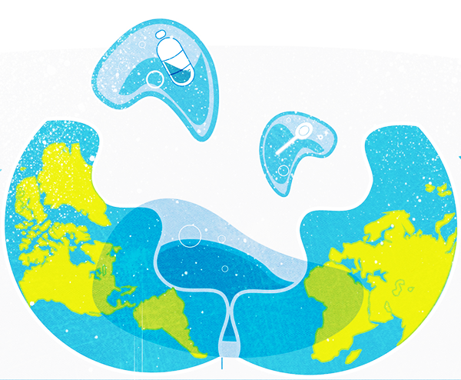
2. Refuse single-use plastics
Did you know that it is estimated that by 2050, there will be more plastic in the sea than fish by weight (www.plasticpollutioncoalition.org)?

It not only takes lots of the Earth's resources to make plastic but it can also take up to 1000 years for plastic to decompose in landfill.

Why not try keeping hold of your plastic bags and reusing them next time you shop?

"Plastic Waste - animation infographics motion graphics" by Svajune Garnyte is licensed under CC BY-NC-ND 4.0

3. Plant a tree
Did you know that one and a half acres of forest is cut down every second (www.conserve-energy-future.com/various-deforestation-facts.php)?
Trees are really important to the Earth as not only are they used for providing us with materials for tools and shelter, they also do crucial jobs for our ecosystem such as:

- Providing us with the air that we breathe
- Preserving the soil
- Providing a living environment for some wildlife

If you have space, why not plant a tree yourself? Alternatively, you could help raise money to plant more trees in and around your local area.

"IMG_0554.JPG" by raYmon is licensed under CC BY 2.0

This resource is available online at ncce.io/med1-2-a2-s. Resources are updated regularly — please check that you are using the latest version.

This resource is licensed under the Open Government Licence, version 3. For more information on this licence, see ncce.io/ogl.

