Arcs and Sectors GREEN

1. Calculate the length of arc AB in the sectors below.

2. Calculate the area of each sector below.

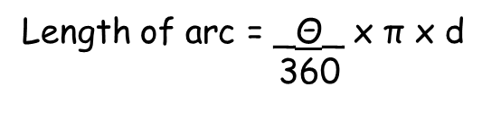
Arcs and Sectors AMBER

1. Calculate the length of arc AB in the sectors below.

AB = ___ x π x ___
360

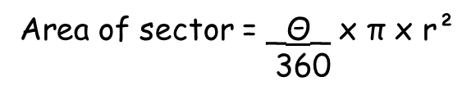
2. Calculate the area of each sector below.

Area = ___ x π x ___²
360

Arcs and Sectors RED

1. Calculate the length of arc AB in the sectors below.

Remember the diameter is double the radius!
AB = ___ x π x ___
360

2. Calculate the area of each sector below.

Don’t forget to square the radius when you enter the question into your calculator

Area = ___ x π x ___²
360

