Area and Circumference of Circles GREEN

Calculate the area and circumference of the circles with the following dimensions:

1) Radius of 4cm 6) Diameter of 5cm
A = A =
C = C =

2) Diameter of 3cm 7) Radius of 6cm
A = A =
C = C =

3) Diameter of 10cm 8) Diameter of 9cm
A = A =
C = C =

4) Radius of 2cm 9) Diameter of 14cm
A = A =
C = C =

5) Radius of 3.5cm 10) Radius of 3cm
A = A =
C = C =

Area and Circumference of Circles AMBER

r = 4cm | A = 12.57cm²  C = 12.57cm | d = 5cm | A = 153.94cm²  C = 43.98cm
d = 3cm | A = 38.48cm²  C = 21.99cm | r = 6cm | A = 50.27cm²  C = 25.13cm
d = 10cm | A = 28.27cm²  C = 18.85cm | d = 9cm | A = 19.63cm²  C = 15.71cm
r = 2cm | A = 7.07cm²  C = 9.42cm | d = 14cm | A = 79.54cm²  C = 31.42cm
r = 3.5cm | A = 63.62cm²  C = 28.27cm | r = 3cm | A = 113.10cm²  C = 37.70cm
Area and Circumference of Circles RED

Calculate the area and circumference of the circles with the following dimensions:
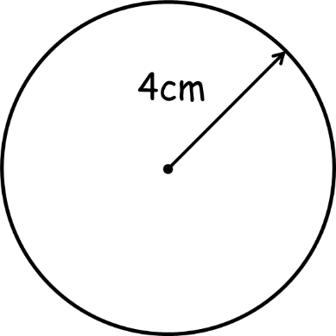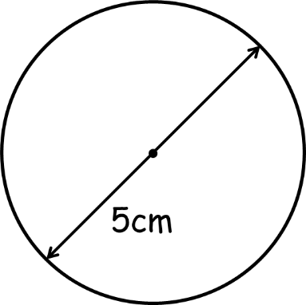
A = πr²
= π x 2.5²
= _____cm²
C = πd
= π x 5
= _____cm
A = πr²
= π x 4²
= _____cm²
C = πd
= π x 8
= _____cm
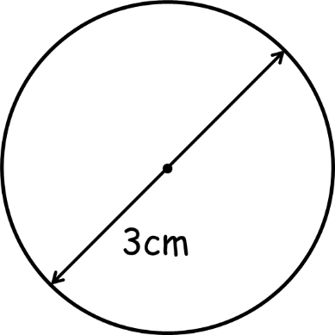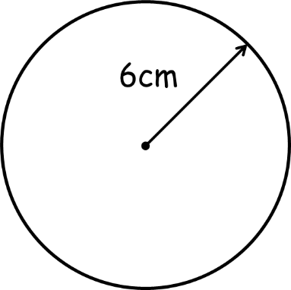
A = πr²
= π x __²
= _____cm²
C = πd
= π x __
= _____cm
A = πr²
= π x 1.5²
= _____cm²
C = πd
= π x 3
= _____cm
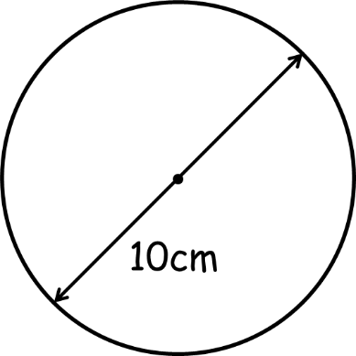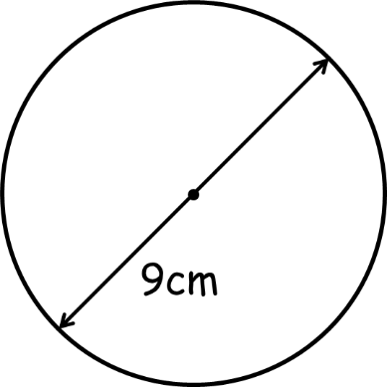
A = πr²
= π x __²
= _____cm²
C = πd
= π x __
= _____cm
A = πr²
= π x __²
= _____cm²
C = πd
= π x __
= _____cm
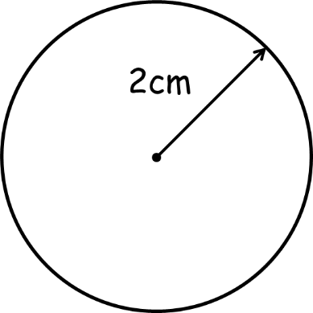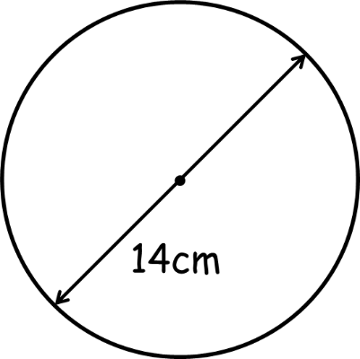
A = πr²
= _______
= _____cm²
C = πd
= _______
= _____cm
A = πr²
= _______
= _____cm²
C = πd
= _______
= _____cm
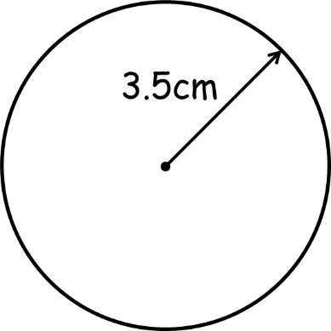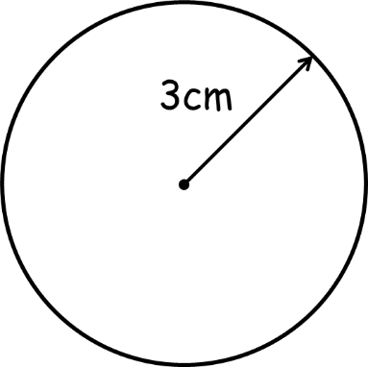
A = πr²
= _______
= _____cm²
C = πd
= _______
= _____cm
A = πr²
= _______
= _____cm²
C = πd
= _______
= _____cm

