Finance for Business revision tasks and notes
Unit 2

Name _____________________________

Mr Simpson

Topic | My understanding of the topic | Key terms that I must know | Extra things I have picked up
Costs and revenue

Profit

Cash flow

Breakeven

Profit and loss accounts

Sources of finance

Balance sheets

How to improve profits

Please ensure that you use this sheet, along with feedback in class to help YOU understand you main strengths and weaknesses.
Key terms:
Fixed cost | Costs that do not change with output- they have to be paid regardless of how much a business produces
Variable costs | Costs that do change with output- these costs are directly linked to the product or service
Start-up cost | Costs that a business has to pay when the business sets up. For examples, fixtures and fittings
Operating costs (running costs) | Costs that have to be paid for the day to day running of the business. For example, heat, light, rent etc…
Total costs | TC= FC + VC
Revenue | This is the money that comes into the business. It is also known as turnover or revenue
Profit | This is the amount of money that the business earns AFTER paying for all of its costs
Break-even | Level of output where total revenue = total costs
Margin of safety | This is the difference between your break-even point and the number of units you expect to sell
Cash flow forecasting | This is a forecast the business makes for what it expects to have coming into the business and out of the business
Inflows | Money coming into the business
Outflows | Money going out of the business
Cost of sales | Costs linked directly with the production of a product
Gross profit | GP= Sales- Cost of sales
Net profit | NP = Gross profit - expenditure
Income statement (profit and loss) | A statement of income and expenditure- usually produced every 12 months
Balance sheets (statement of financial position) | A statement outlining the financial position of the business
Assets | Things that the business owns
Liabilities | Things that the business owes
Sources of finance | Ways in which the business can raise money. These can be internal (from within the business) and external (outside of the business)
Budgeting | The process of planning income and expenditure within a business

Costs
Fill in the missing words:
Business have to pay for items when the first set up a business. These are known as _____________________________. These costs can be very expensive so the business owner may have to get finance from other places such as the bank or an investor. The costs that the business has to pay for the day to day running of the business are call_____________________.
Examples of these costs can include rent, heat and light and wages.
Think of as many start up and running costs for a small business of your choice:
Type of business: _____________________________________________________________________
Start-up costs | Running costs

When looking at costs, we can also look at fixed and variable costs. Fixed costs DO NOT change and have to be paid regardless of output. This is things such as rent, salaries, heat and light, Variable costs DO change directly with output. These are costs that you will have to pay depending on how much you do/produce. For example, if you make one loaf of bread and it cost you 30p for materials you would pay 30p. For 10 loafs it would costs 10 x 30p (£3).

To work out the total costs for a business you need to add all fixed and variable costs together. What is the formula that we case use for this?

Understanding profits/Profit and loss accounts (income statement)
All businesses must make a profit if they are to ensure that they can survive. When looking at the income statement (profit and loss account), there are two different types of profit that we can see. These are:
Gross profit which can be defined as: _______________________________________________________________________________________________________________________________________________________________________________________________________________________________________________________________________________________________________________
Net profit which can be defined as:
_______________________________________________________________________________________________________________________________________________________________________________________________________________________________________________________________________________________________________________

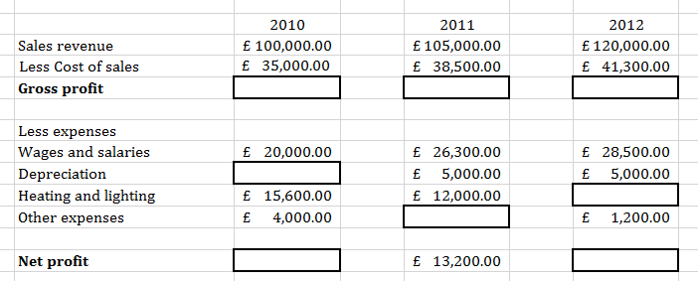
Fill in the blank spaces below in order to work out the correct gross and net profit figures. For depreciation- assume that it is £5000 each year.
£ 17,800

Extension: what would the profit figure be is the heat and lighting actual cost £28,000 in 2011? (show your workings)

How can profits be improved?
Have a look at the following link and suggest how a business might improve its profits:
http://www.businessstudiesonline.co.uk/live/index.php?option=com_content&view=article&id=55&Itemid=33

Break-even
Break-even is “the level of output when total revenue = total costs”. A business MUST understand how many units it needs to sell before it can begin to think about making a profit.
You can calculate a break-even point via a break even chart and by using the breakeven formula. Have a look for the break-even formula and add it into the space below:

The business will have to understand it fixed costs, variable costs and sales revenue in order to be able to calculate break even.
Task 1:
Correctly label the diagram below.
Task 2:
On the diagram identify the following areas. 1) Where the business is making a loss 2) Where the business is making a profit 3) Where the business is breaking even

Budgets
Budgets are used by business owners to help them understand the potential costs and income that they can expect over a given period of time. Without budgeting, the business will not be able to control its costs and the business could fail. When a business checks it actual performance against its predicted performance it is called budgetary control.
Look at the table below and discuss the information in the budgets. If the figures are better than expected (i.e. they either bring more into the business or cost in less), it is call a ‘favourable variance’. If the figures are worse than expects or have cost the business more than they thought it would, it is call an ‘adverse variance’.

Look at the table below and identify the adverse and favourable variances:

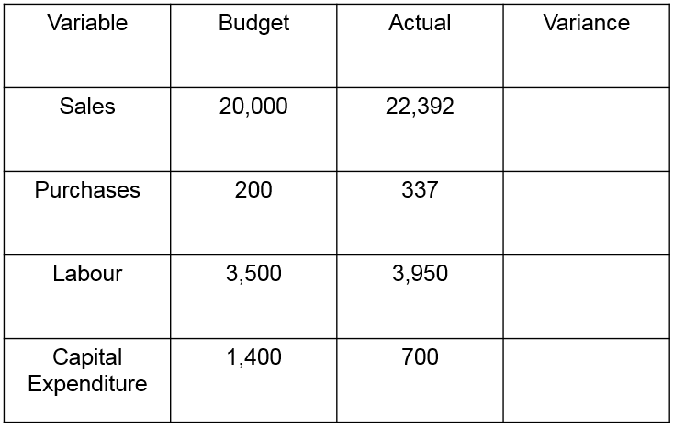
Extension:
Pick one of the budgets and discuss how you would improve it so that the business is better off.
_______________________________________________________________________________________________________________________________________________________________________________________________________________________________________________________________________________________________________________________________________________________________________________________________________________________________________________________________________________________________________________________________________________________________________________________________________________________________________________________________________________________________________________________________________________________________________________________________________________________________________________________________________________________________________________________________________________________________________________________________________________________________________________________________________________________________________________________________________________________
Cash flow forecasting
A cash flow is used to predict how cash will flow through a business over a period of time in the future.
The business will need to have an understanding of all of the money coming in to the business (inflows) and all of the money going out of the business (outflows). Identify the inflow and outflows from the table below:
Example | Outflow? (tick) | Inflow? (tick)
Sales Turnover
Purchase of raw materials
Paying dividends
Debtors paying
Creditors paid
Salaries
Sale of machinery
Bank loan received
Grant
Injection of owners capital
Purchase of machinery
Electricity bill
Tax
Interest on loan

Business must ensure that they manage the inflow and outflows of the business. If they do not have a reasonable balance of money coming in against money going out it can result in huge issues.
Have a look at the following article and see how a failure to collect income from debotrs (people that owe a business money) caused the collapse of the building firm!
http://www.building.co.uk/major-contractors-%E2%80%98owed-over-%C2%A313m%E2%80%99-to-collapsed-me-firm/5064520.article
Cash flow forecasts
The cash flow key terms:
Net cash flow
Cash inflows/Receipts
Opening balance
Cash outflows/Payments
Closing balance

How much cash is coming into business from product sales, sales of assets, loans from bank, grants from government, and other sources of finance
How much cash is going out of business, such as expenses, wages, raw materials, buying new machinery, tax payments and dividend
The difference between cash flowing in and out of the business.
How much cash a business has at the start of a time period – day, week, month.
How much money is left at end of that period – day, week, month

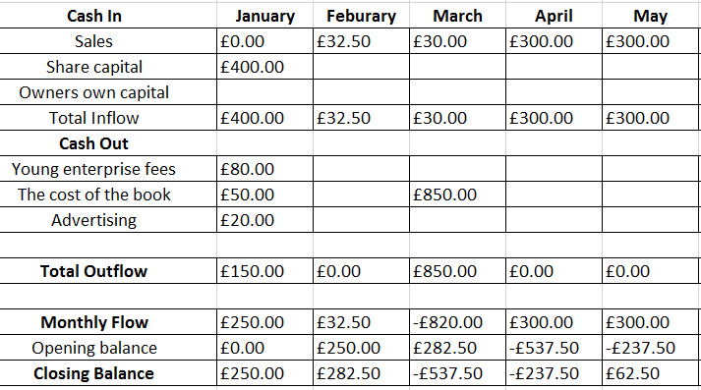
The cash flow forecast for a business is shown in a document similar to the one
Task:
Mr Smith owns a bakery and he initially worked out the cash flow forecast for his business which can be seen below:
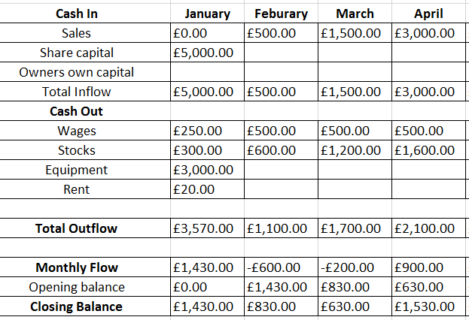

Mr Smith forgot that he had to make a payment of £1500 in March for equipment that was due for delivery. He also took on one more member of staff which means that his wage bill for March and April should be £1000 not £500. Fill in the blanks below:
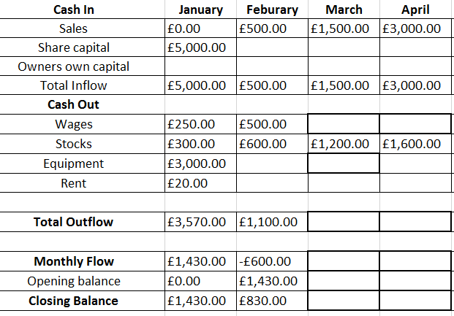

Balance sheet (statement of financial position)
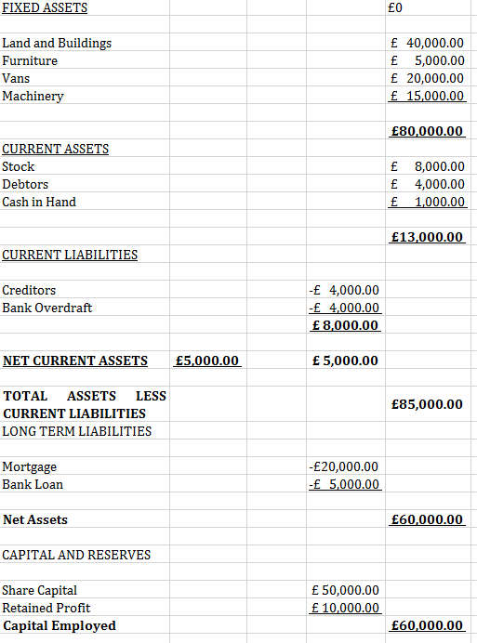

The balance sheet shows the financial position of the business. It lists all of the assets (what the business owns) and all of its liabilities (what the business owes). On the balance sheet the NET ASSET figure and the CAPITAL EMPLOYED figure must always balance.

Balance sheet task:
Read through the information and fill in the blanks. Remember that the balance sheet MUST balance!!
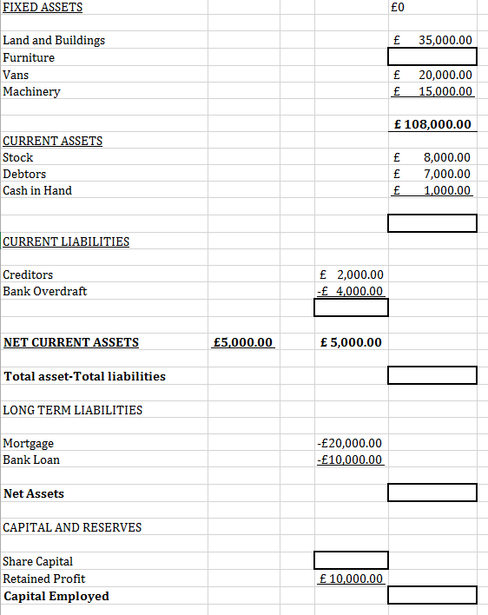

How is a business financed?
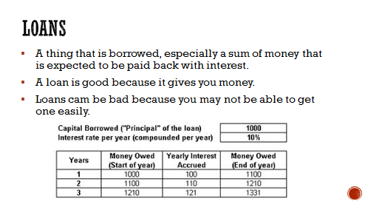
There are a number of ways that businesses can be financed. This can be through internal or external sources. Look at the images below and decide whether it is internal or external finance.

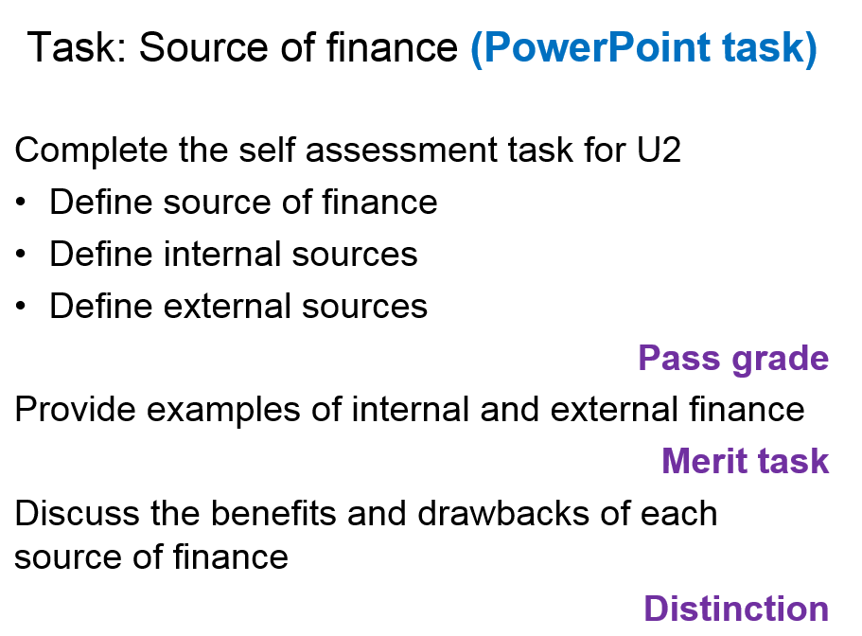
Task two:

