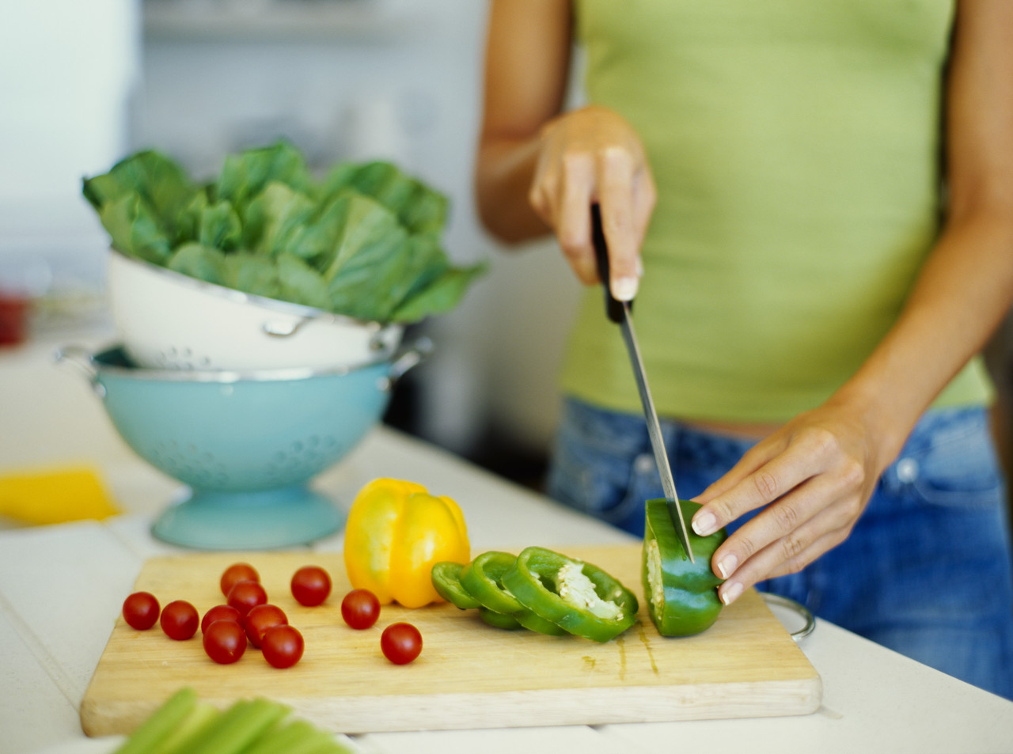

Food Technology Activity Pack

In this pack you will find lots of activities and popular recipes to try at home that you may have cooked in school, have a go at the ones you feel comfortable with, you will surprise yourself! If you do not have all the ingredients, you can substitute them for others that you can find in your kitchen cupboards, fridge or freezer.

Try not to be bored!
Happy cooking!!

Name: ______________________

Number of people in your family group: _________

What is this Scheme of Work about?
Food Technology is one area within Design and Technology. In this Scheme of Work, we want you to gain an understanding of ingredients and cooking methods used to make quality food products. We also want you to gain useful life skills in preparing nutritious meals. This unit builds on the work you did in Year 8. It will teach you more challenging food preparation skills and give you the confidence and ideas to design your own healthy meal.

What do these symbols mean?
You will find the following symbols posted throughout the booklet. They tell you of a particular activity.


The Chef’s Hat - Cooking Activity
The Chef’s hat means that there is a cooking activity to complete. This focuses on your food preparation skills and will give you opportunities to practice food hygiene, food preparation, knife skills, cooking skills and experiment with ingredients.


The Popcorn Symbol – DVD/Video
The popcorn symbol means that there is a DVD/video to watch. Many of the videos can be viewed on the Internet so you can also watch them at home.


The @ Symbol - Internet Activity
This symbol tells you to complete a task on the Internet. There are plenty of opportunities for you to use the Internet throughout this project. You will particularly need to use a new website called Licence to Cook to complete the assessment activities.


The A+ Symbol - Assessment for Learning
There are many opportunities to reflect on your progress and improve things before your teacher awards a final level. Read the Level Descriptors carefully! The Level Descriptors tell you exactly how to get a good level in this unit.


Scheme of Work
You don’t need to follow this timetable strictly

Week | Lesson 1 | Lesson 2 | Homework
1 | - Introduction.  - 4Cs Food Standards Agency Video  - 4 Cs to Food Hygiene.  - Food poisoning | - Demonstration – Reduction Sauces.  - Basic Ragu Sauce  - Ratatouille | - Spelling errors.  - Food Poisoning Word search
2 | - Practical – Tomato Ragu with pasta or Ratatouille with rice. | - Evaluating Food Products  - Evaluation of Tomato Ragu/ Ratatouille | - Licence to Cook – Protecting Tutorial 1&2.
3 | - Starch sauces and gelatinisation  - Demonstration of Macaroni Cheese | - Practical: Macaroni cheese | - Evaluation of Macaroni cheese
4 | - Discussion about the Eatwell plate.  - Eatwell Activities? | - Demonstration: Spinach, Potato and Chickpea Curry  - Demonstration Lamb Korma | - Internet quiz. Are you a healthy eater?
5 | - Read notes on meat. Discussion about choosing, storing, cooking meat.  - Research curry recipes. Complete research activities. | - Plan to make your own curry. | - Licence to Cook Healthy Eating Tutorials.  - Complete plan to make your own curry.
6 | - Practical: Make the curry that you designed. | - Demonstration: Risotto  - Recipe research of ingredients you can use in risotto.  - Design your own risotto. | - Licence to Cook- Shopping Tutorial.  - Evaluation of curry.
7 | - Recipe for research of risotto.  - Plan of making for risotto. | - Practical: Risotto | - Evaluation of risotto.
7 | - Demonstration: Stir-fry  - Design your own stir-fry – vegetables, meat and sauce. | - Research recipe ideas for stir-fry.  - Plan of making for stir-fry. | - Finish research and plan of make of risotto.
8 | - Practical: Stir-fry | - Read design brief to design a healthy meal.  - Brainstorm ingredients and ideas.  - Discussion of Survey | - Survey
9 | - Disassembly | - Design ideas  - Plan of making | - Finish design ideas and plan of making,
10 | - Practical: Healthy meal. | - Evaluation
The 4C’s for Good Food Hygiene
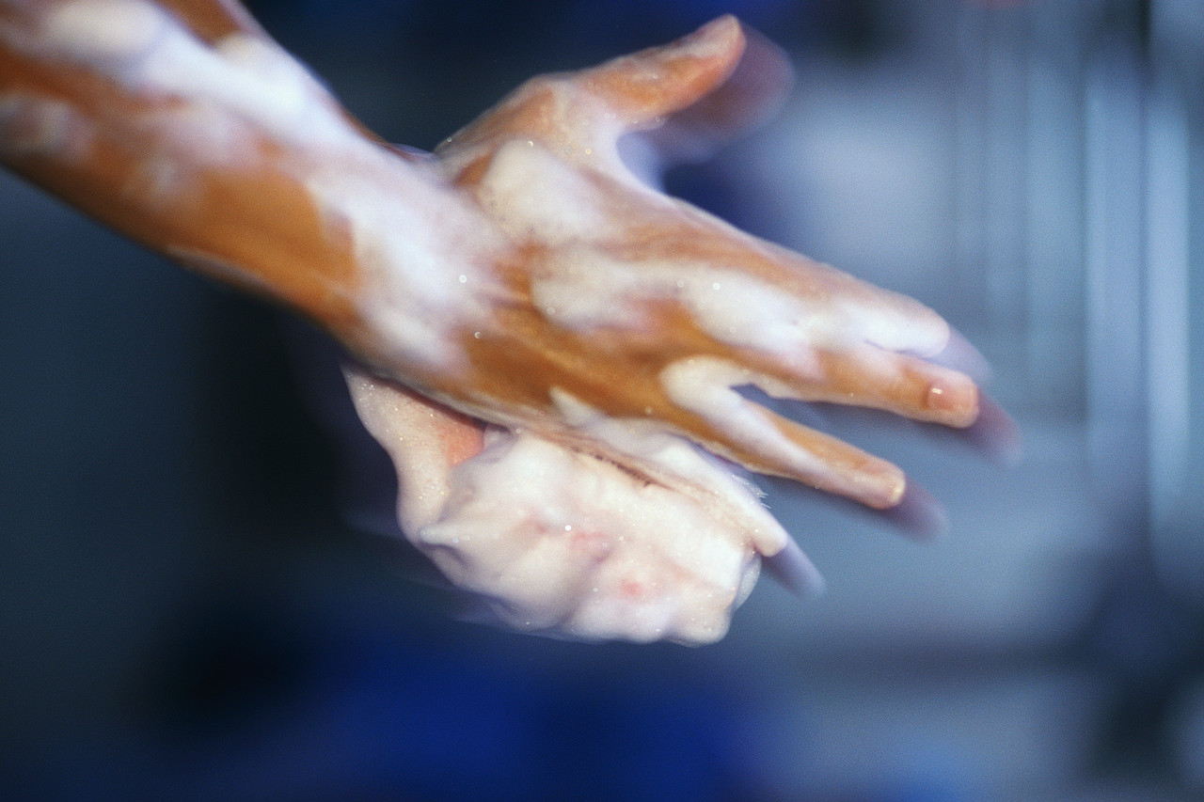
Learning Objective
By the end of this activity, you should know the 4C’s for good food hygiene.

Keywords: hygiene, food poisoning, cross-contamination, temperature, bacteria (try using the word bacteria rather than germs.)

Food hygiene is about preventing food poisoning. Food poisoning bacteria grow very quickly in food if it is not handled properly, cooked properly or stored properly. There are laws, which control how food manufacturers can prepare and sell food. Statistics show that you are more likely to get food poisoning from a home -made meal than you are from a bought one. What are the symptoms of food poisoning?

Make a list of the types of food that are most likely to give you food poisoning. These foods are usually high in moisture and protein and are called ‘high risk foods.’

The Popcorn Symbol – DVD/Video
Watch the video from the Food Standards Agency and read brochure titled Preventing Food Poisoning. Write food hygiene rules of each of the 4C’s. (http://www.flyonthewall.com/FlyBroadcast/FSA/BacteriaBiteBusiness/ )

The 4C’s

- C_____________

- C_____________

- C_____________

- C_____________

Food Poisoning

Food poisoning can happen when contaminated food or drink is consumed. It can cause vomiting, diarrhoea, stomach pain and weakness. In very extreme cases, food poisoning can cause death.

Food poisoning in the UK is on the increase. In 1982, there were 14,253 reported cases of food poisoning. In 1996, there were 83,233 cases of food poisoning. Food poisoning doubles in the summer months. It usually occurs from eating a home-cooked meal or barbeque, either by not washing hands, cross-contamination, not cooking chicken and minced meat properly or incorrect storage.

The food industry must follow strict laws about the way in which food must be cooked and stored. These laws are set out in the Food Standards Act 1999.

Internet Activities – Licence to Cook and Research Activities
- Log onto the Licence to Cook Website and complete Protecting – Tutorial 2.
- How good are you at finding information on the Internet? Use the Google or another search engine or a textbook to find the answer to following questions.

1. What conditions do food poisoning bacteria need to grow?

2. In what foods do the following food poisoning bacteria grow?

Campylobacter ____________________________________________
Salmonella ____________________________________________________________
Listeria monocytogenes __________________________________________________
Escherichia coli – E. coli __________________________________________________

3. In the food industry, define the phrase ‘danger zone’?

4. At what temperature does the Food Standards Act 1999 say that high-risk foods be cooked?

5. What temperature should high-risk foods be stored?

Food Hygiene and Food Poisoning Wordsearch

There are the names of food poisoning bacteria or high-risk foods in this word search below. See if you can find them.
L | E | D | S | T | A | F | L | I | S
B | A | B | R | S | R | I | C | E | A
O | P | A | M | Q | U | S | F | O | L
T | U | C | H | U | R | H | D | Y | M
U | S | T | O | R | A | G | E | M | O
L | R | E | C | O | L | I | G | I | N
I | S | R | L | E | A | J | G | L | E
S | H | I | G | H | R | I | S | K | L
M | S | A | R | M | E | A | T | Y | L
S | U | L | I | S | T | E | R | I | A

Words
Bacteria | eColi | Botulism | Fish
High risk | Salmonella | Meat | Milk
Storage | Listeria | Eggs | Rice


Common Spelling Errors in Food Technology
Circle the correct spelling

Nife | Knife
Vegetables | Vegatables
Ingredients | Ingrediants
Potatoe | Potato
Potatoes | Potatos
Tomatos | Tomatoes
Self-raising flour | Self-raising flower
Cauliflour | Cauliflower
Brocolli | Broccoli

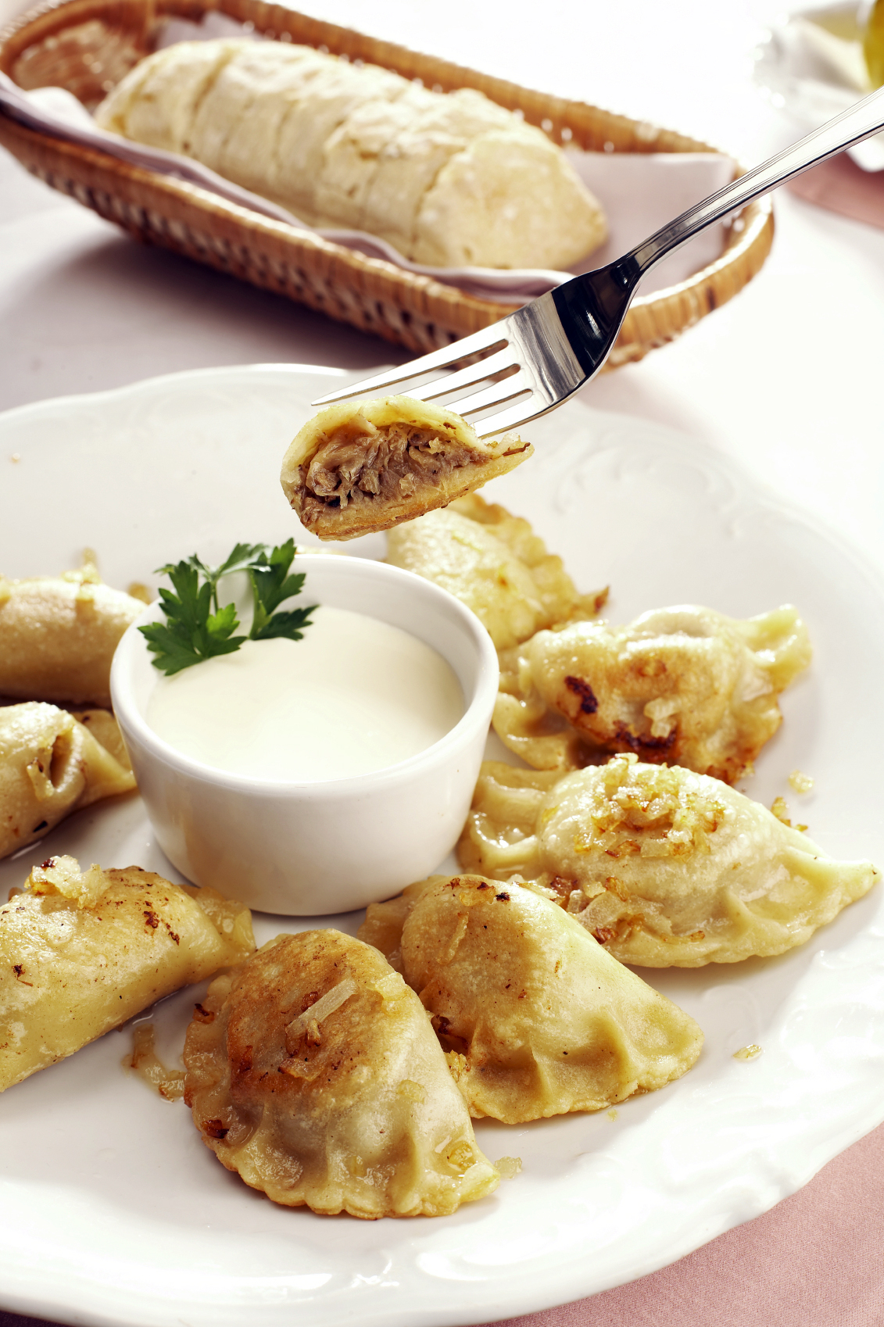
Savoury Sauces

A tasty sauce can transform a dish from a plain fare to a delectable delight; yet making one can be as simple adding a few drops of vinegar to a pan after frying meat or could be as complicated as blending butter and flour or adding an emulsifying agent such as an egg.

There are lots of different sauces.

- Gravies are made from the juice of meat. Sometimes stock is added for extra flavour.

- Roux sauces are a cooked mixture of flour and butter. The white sauce béchamel is the best-known example of a roux-based sauce, and a good one to master as it can be used in many different dishes, including macaroni cheese, lasagne and soufflés. Cheese, onion, parsley and mushroom are among the many possible variations of the béchamel recipe.

- Emulsifying sauces are the rich, smooth, utterly luxurious sauces made with emulsified eggs and butter are among the most intimidating for beginners because they can easily curdle if you don't pay careful attention while making them. They are well worth the effort however, as they turn simple pieces of poached fish, shellfish, chicken and green vegetables into gourmet treats.

- Vegetable and herb sauces. These sauces are vibrant and zingy rather than rich and creamy and, overall, they are healthy too, as their fresh ingredients are high in antioxidants.

- Ketchups, relishes and Asian oriental sauces. These sauces can be stored in the cupboard are an essential part of the cook's repertoire. Sauces such as cranberry and Cumberland, or creamy horseradish are a boon and require no last-minute preparation to serve. There are also Asian and oriental sauces such as soy sauce, sweet chilli sauces, Thai and Vietnamese fish sauces, Chinese hoi sin and oyster sauces.

- Reducing sauces. The simplest technique for thickening a sauce is reduction. It is also popular because it does not require additional fat or starch. The sauce is simply simmered to evaporate some of the water content, resulting in an intensely flavoured yet clean-tasting sauce.

- Pureeing sauces. Pureeing is the method used most often for sauces made from raw or cooked vegetables or fruit. It gives a smooth creamy texture without the addition of cream so sauces made this way are a healthy option. Eg. Guacamole and hummus.
Classic Tomato Sauce (Reduction Sauce)

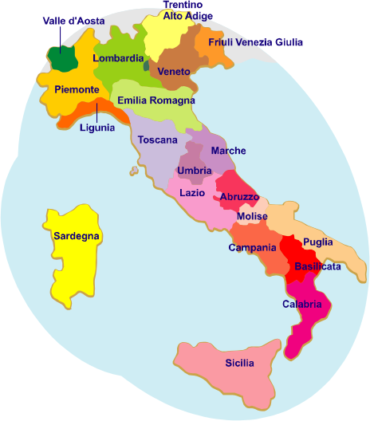
Ragù is an Italian term for a meat-based sauce, which is traditionally served with pasta. In this activity, you will make a vegetable-based sauce to serve with pasta.

Learning Objective
In this activity, you will:
- learn how to make a sauce using the reduction method;
- demonstrate safe use of a knife and other small tools and equipment;
- prepare a range of fresh ingredients, e.g. peeling, slicing;
- Use the cooker safely.

Keywords: sweat, fry, boil, simmer, reduce.

Ingredients
1 onion
1 clove garlic, peel and crush
1x15ml spoon oil
1 x 400g canned chopped tomatoes
Handful of fresh basil
black pepper

Equipment
Knife, chopping board, garlic press, measuring spoons, saucepan, wooden spoon, saucepan.

Method
1. Peel and chop the onion and peel and crush the garlic.
2. Fry the onion and garlic in the oil for 5 minutes, until soft. Be careful not to burn the onion and garlic otherwise it will make your product taste bitter.
3. Add the tomatoes and tear in the basil leaves.
4. Add a few twists of black pepper, then allow to simmer gently for 30 minutes (longer if possible).

Optional
You may wish to serve the tomato ragu with pasta:
- After 15 minutes, put a large saucepan of water on to boil. When rapidly boiling, add the 100g pasta and cook for around 10 minutes until al dente. Drain;
- Mix the cooked pasta and tomato sauce together.

Top tips
- Use dried herbs if you do not have fresh.
- Add ½ red chilli, for a sauce with a kick.
- Add 75g mushrooms and 75g courgette, after stage 2, for a simple veggie sauce.
- Add and brown 200g minced beef after stage 2 for a simple meat sauce.
- Stir-in black olives and tuna.
- Add chicken or chickpeas and serve over rice.
- Pour the basic sauce over white fish, sprinkle with cheese and bake for 20 minutes until golden.

Skills
Using the hob | Onion preparation (Bridge hold / Claw grip) | Simmering (heat control)

Ratatouille (Reduction Sauce)

Ratatouille is a traditional French stewed vegetable dish, originating in Nice. It can be served as part the main part of a meal with rice or as an accompaniment of vegetables with meat or chicken.


Learning Objective
In this activity, you will:
- learn how to make a sauce using the reduction method;
- prepare a range of fresh ingredients, e.g. peeling, slicing;
- use the cooker safely;
- Apply your knowledge of reduction sauces to make ratatouille.

Keywords: sweat, fry, boil, simmer, reduce.

Ingredients
1 onion
1 clove garlic
1/2 small aubergine
1/2 green pepper
1/2 courgette
1 can chopped tomatoes (400g)
1 x10ml spoon oil
1 handful fresh basil

Equipment
Chopping board, knife, garlic press, saucepan, measuring spoons, wooden spoon, can opener.

Method
1. Prepare the vegetables:
- peel and chop the onion;
- peel and crush the garlic;
- dice the aubergine;
- de-seed and chop the green pepper;
- Slice the courgette.
2. Sweat the onion and garlic in the oil for 2 minutes.
3. Add the aubergine and fry for a further 3 minutes.
4. Add the pepper, courgette and tomatoes.
5. Stir-in the torn basil leaves.
6. Bring to the boil and then simmer gently, with the lid on the saucepan, for 20-30 minutes.

Top tips
- Use dried herbs if you do not have fresh basil.
- Go for different vegetables - try adding olives, mushrooms, red inions, peas or beans.
- Serve with rice, potatoes or bread for a low fat snack.

Skills
Using the hob | Onion preparation | Bridge hold | Claw grip

Use this space to write an ingredient list for the design of your own Ratatouille. Add high protein ingredients that would make Ratatouille a complete meal for vegetarians.

Evaluating Food Products

Sensory analysis involves the measurement of food characteristics such as taste, texture, appearance, smell, and aftertaste. It is used in industry evaluate and develop the best possible product. Different types of tests are used to obtain different information. Three main tests are used:
- descriptive
- preference tests
- Discrimination tests.

Descriptive Tests
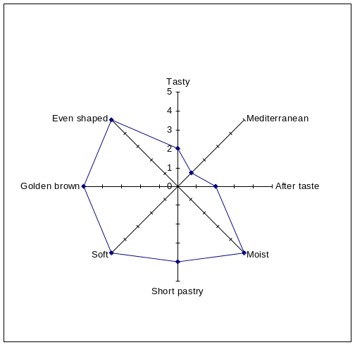
This is the most common type of test. It is sometimes called a sensory attribute or attribute test. This test involves giving a score out of 5 for each sensory characteristic.

Sensory Analysis | Score out of 5
Tasty | 2
Mediterranean | 1
After taste | 2
Moist | 5
Short pastry | 4
Soft | 5
Golden brown | 3

Preference Tests
These tests are used to find out which product tasters prefer. There must be two or more products. The two examples below are called the Ranking Test and the Hedonic Ranking Scale.

Ranking test | Rank in order of preference
Product A | 3
Product B | 1
Product C | 2

Hedonic ranking scale | Like a lot   | Like a little   | Neutral   | Dislike a little   | Dislike a lot  
Product A |  | ✓
Product B |  |  | ✓

Evaluation of Tomato Ragu or Ratatouille

Sensory Attribute Test


1. Tick the appropriate box on the hedonic scale for your product.

Hedonic scale | Like a lot | Like a little | Neutral | Dislike a little | Dislike a lot
Tomato Ragu/ Ratatouille

2. Describe the strengths and weaknesses of the meal?

3. What do other people think of your product?

4. Suggest changes would you make to the ingredients, cooking times and temperatures and/or appearance to improve the product? (Be specific about the improvements that you would make.)

Assessment for Learning
□ Working towards Level 4 – I have written an evaluation and included strengths, weaknesses and suggestions for improvement.
□ Working towards Level 5 – I have written a detailed evaluation, including strengths, weaknesses and clear suggestions for improvement (eg. suggest changes to ingredients and quantities or changes to cooking processes.).
□ Working towards Level 6 – I have written a detailed evaluation, taking into account what other people said, and have several very clear suggestions for improvement.
Starch Sauces

Sauces are an important food product. They add flavour, colour, moisture and nutritional value to food. Starch is a polysaccharide carbohydrate and is found in wheat, corn, rice and potatoes. Starches are often used to thicken a sauce by a process known as gelatinisation.

Starchy sauces can be thickened with

What starches are used to thicken the sauces in the following foods?

Macaroni cheese |  |  | Lemon meringue pie
Lasagne cheese sauce |  |  | Chicken and mushroom pie
Leek and potato soup |  |  | Spinach, potato and chickpea curry
Commercial custard powder |  |  | Gravy

How does starch thicken a sauce?
Starch thickens a sauce by a process called gelatinisation. This is where starch granules swell and thicken when they are heated with a liquid. When the starch granule is heated with water, the wall of the starch granule softens and the granules absorb the liquid and swell and the mixture begins to thicken. Gelatinised starch products are easier for the body to digest than are uncooked starchy products.

Rules for Gelatinisation of Starch Flours
Blending with a separating agent - starch (flour) must be blended with a separating agent before it is heated, otherwise the starch granules join together to form lumps. The separating agent may be:
- Melted fat (e.g. melted butter in a roux.)
- cold water or another cold liquid such as milk
- other dry ingredients – such as sugar

Stirring – The product needs to be stirred continually when it is heated, otherwise the starch granules settle to the base on the saucepan and the sauce becomes lumpy.

Temperature – the temperature needs to be high enough so that the mixture will simmer, but not so high, that it will burn. The product will not gelatinise if boiling point is not reached.

Amount of liquid – The consistency of the gelatinised product depends on the proportion of starch to liquid. The greater the amount of starch, the thicker the product will be.
Macaroni Cheese (Roux Sauce)

Learning Objective
In this activity, you will:
- learn how to make a roux (blend of butter and flour sauce);
- demonstrate safe use of the cooker and other small tools and equipment;
- prepare a range of fresh ingredients, e.g. grating;
- Understand the principle of gelatinisation.

Keywords: stir, boil, simmer, bake, separating agent.

Ingredients
Quantity | Ingredient | Function
250ml | Milk | For the béchamel sauce
30g | Butter | Separating agent. Prevents flour from forming lumps in the sauce.
20g | flour | Thicken the sauce (gelatinisation)
175g | Cheddar cheese (grated) | Taste
200g | Macaroni | Forms the bulk of the product

Equipment
Ovenproof casserole dish
2 saucepans – 1 for pasta and the other to make the sauce
Measuring jug
Wooden spoon
Measuring equipment
Grater
Colander

Method
- Preheat the oven to 220ºC / Gas 7.
- Boil a saucepan of water. Add pasta and bring to the boil.
- In another saucepan melt the butter over a medium heat and, when foaming, add the flour. Stir well. The mixture will be thick to start with. Do not allow it to burn.
- Gradually add the milk to the butter and flour mixture, stirring constantly. Add the milk slowly until it is all used up.
- The finished white sauce is called a béchamel sauce. Simmer and stir the béchamel sauce until it has a rich, smooth consistency and is free from lumps.
- Add 2/3 grated cheddar to the béchamel and stir until melted and smooth. Turn off the heat. Once the cheese is added to the béchamel, do not allow it to boil or the cheese will become stringy.
- Drain the pasta using a colander. Put the pasta back in the saucepan.
- Mix the cheese sauce to the pasta and mix thoroughly.
- Place the macaroni into a shallow ovenproof dish and sprinkle with remaining cheese. Put it in the preheated oven to bake until golden brown, about 15 minutes.
- Serve individual portions straight from the baking dish.

Suggest ingredients you would add to improve the recipe

The Eatwell Plate

If you want to get the balance of your diet right, use the Eatwell Plate.

The Eatwell plate makes healthy eating easier to understand by showing the types and proportions of foods we need to have a healthy and well balanced diet. The Eatwell plate shows how much of what you eat should come from each food group. This includes everything you eat during the day, including snacks.

Study the Eatwell Plate and then complete the activities at the bottom of the page.

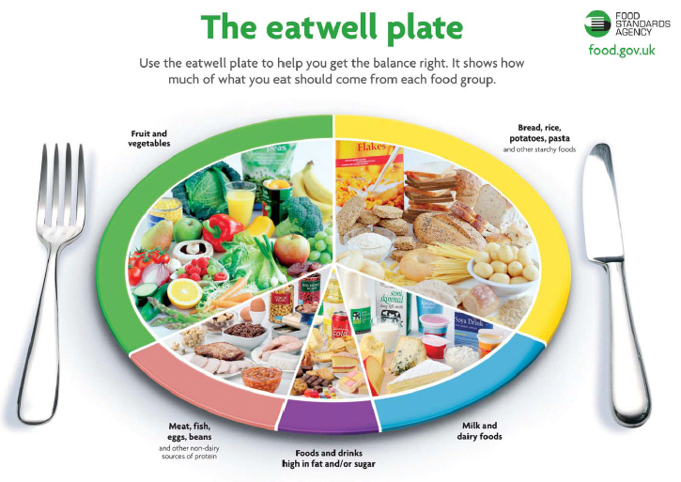

Internet Quiz
Try out these 2 Internet quizzes on the Food Standard Agency website.
Are you a healthy eater? Do you know what is good for you?
Do you know what is good for you?
http://www.eatwell.gov.uk/agesandstages/teens/eatbetterquiz1/ what was your score?

Are you a healthy eater?
http://www.eatwell.gov.uk/agesandstages/teens/quiz2/ what was your score?

Is Amy eating well?
You can do this for a daily meal plan to see if you are getting a balanced diet!

Here are all the foods that Amy ate yesterday.

Glass of milk for breakfast
Packet of crisps
Chocolate muffin at break
Chip, cheese and gravy for lunch. A can of cola.
Four slices of bread with peanut butter at 4pm
Cheese and ham pizza for dinner
Two packets of crisps and a ½ a packet of Jaffa cakes

Write the foods that Amy ate onto the Eatwell Plate below, and then create one for you and your family.

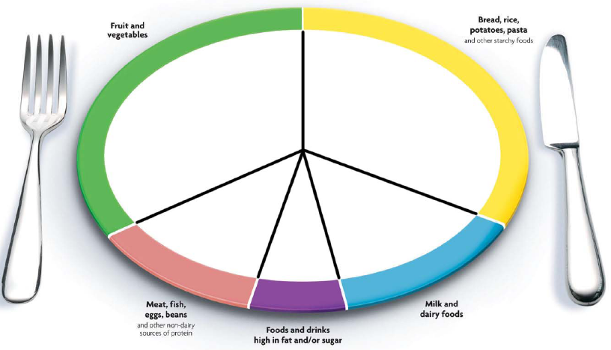

Think about it!
1. Which section have too many foods in them?

2. Which sections of the Eatwell plate do not have enough foods in them?

3. How can Amy change the foods she eats so that she does not have so many in the ‘high in fats and sugar’ section?

4. Suggest three healthy snack foods Amy could eat instead of crisps, cakes and chocolate.

Are you eating well?

Write the foods that you ate yesterday on the Eatwell plate.

Think about it!
1. Which section(s) have too many foods?

2. Which sections of the Eatwell plate do not have enough foods in them?

3. Suggest a healthy eating plan for 1 day that would fit the Eatwell plate?

Breakfast
Break
Lunch
Afternoon Tea
Dinner

Internet Activity: Licence to Cook
- Complete Healthy Eating Tutorial Two and the Assessment on www.licencetocook.org.uk

Spinach, Potato and Chickpea Curry
A year 9 favourite!!

A curry is the English description of any variety of spicy dishes, best known in Indian, Pakistani, Bangladeshi, Sri Lankan, Nepali, Indonesian, Malaysian, Thai, and other South Asian and Southeast Asian cuisines. The next two recipes teach you about making a curry dish in one pan. This is an opportunity for you to be creative and select ingredients that could be combined into the dishes.

Learning Objectives
In this activity, you will:
- learn how to make a curry using minimal pieces of equipment;
- demonstrate safe use of the cooker and other small tools and equipment;
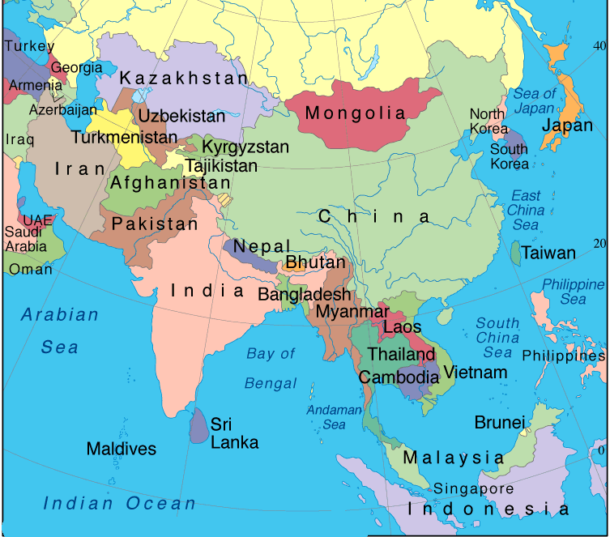
- prepare a range of fresh ingredients, e.g. peeling, chopping, crushing garlic, de-seeding chilli;
- buying, storing, preparing and cooking meat;
- Demonstrate fry, boil and simmer.

Keywords: fry, boil, simmer, cross-contamination.


Ingredients
1x onion
1x clove garlic
1 x 5ml spoon oil
2x 15ml spoons curry paste
300ml water
1x large potato
200g chopped tomatoes
200g chickpeas, canned (drained)
2x handfuls of fresh spinach

Equipment
Knife, chopping board, garlic press, frying pan, measuring spoons, measuring jug, wooden spoon, can opener.

Method
1. Prepare the onion, garlic and potatoes:
- slice the onion;
- peel and crush the garlic;
- peel and cube the potatoes.
2. Fry the onion and garlic for 2 minutes in the oil.
3 Stir in the curry paste, potatoes and water.
4. Add the tomatoes and chickpeas, and then allow to simmer for 20 minutes, until the potato is tender.
5. Stir in the fresh spinach, and allow to cook for a further 2 minutes.
6. Serve.
Top tips
- Serve with boiled or pilau rice, naan bread or chapatti you made.
- Replace the tomatoes with thinly sliced courgettes, peppers or okra.
- Batch cook – freeze portions for a rainy (busy) day

Skills
Using the hob | Bridge-hold | Claw-grip | Stir-fry | Combining

Choosing, Storing and Cooking Meat
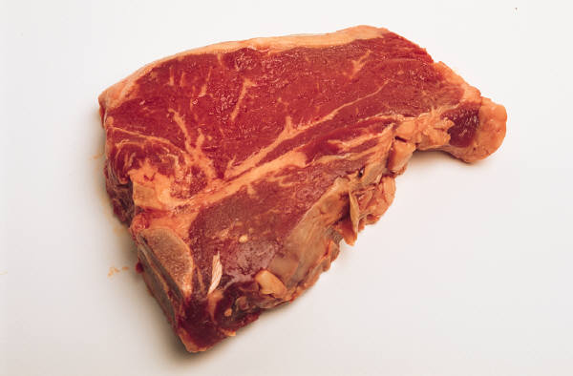
Meat is a good source of protein and vitamins and minerals, such as iron, selenium, zinc, and B vitamins. It is one of the main sources of vitamin B12, which is only found in foods from animals, such as ....................................

Cutting down on fat
Some types of meat are high in fat which can raise cholesterol levels. Having high cholesterol increases the chances of developing .................................. When you're buying meat, the type of cut or meat product you choose (and how you cook it) can make a big difference. For example, a lean pork leg joint, roasted medium, typically contains one quarter of the fat of a pork belly joint with fat, grilled (5.5g fat per 100g compared with 23.4g fat per 100g). Fried chicken breast in breadcrumbs contains nearly 6 times as much fat as chicken breast grilled without the skin (12.7g fat compared with 2.2g fat per 100g).
Try to go for the leanest option whenever you can. As a general rule, the more white you can see on meat, the more fat it contains.
Make healthier choices when buying meat
- If you're buying pre-packed meat, check the label to see how much fat it contains and compare products.
- Go for turkey and chicken, without the skin, because these are lower in fat.
- Try not to eat too many meat products such as ...................................................................., because these are generally high in fat. They are often high in salt too.
- Remember that meat products in pastry, such as pies and sausage rolls, are very high in fat.

Cutting down on fat when cooking meat
If you're trying to have less fat, it's a good idea to cut off any visible fat and skin before cooking because fat, crackling and poultry skin are much higher in fat than the meat itself.
- ............................meat rather than frying.
- Try not to add extra ...................................... when cooking meat.
- Roast meat on a metal rack above a roasting tin, so fat can ...............................
- Try using smaller quantities of meat in dishes and more vegetables, pulses and starchy foods.

Cooking meat safely
It's very important to cook meat properly to make sure that any .................................................... have been killed. Otherwise you might get food poisoning.
Bacteria can be found all the way through certain meat. So this means you need to cook the following sorts of meat until the juices run clear and there is no pink or red left in them:
- poultry and game such as chicken, turkey, duck and goose
- burgers and sausages
- kebabs
- rolled joints
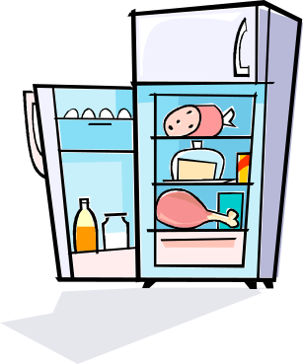
Storing meat safely
Store raw meat/poultry in clean sealed containers on the....................................... fridge, so it can't .................................................................. When you have cooked meat and you're not going to eat it straight away, cool it as quickly as possible and then put it in the fridge or freezer. Remember to keep cooked meat separate from raw meat on the ................................................................
Store raw meat on the .............................!

Why are red chopping boards used for raw meat in the Food Technology room?

Chicken Korma
Another Y9 favourite!!

The korma is a type of mild curry dish that originated in India and is made with yoghurt or coconut milk to add a creaminess to the curry. Both vegetarian and non-vegetarian kormas exist. In this recipe we use chicken but if you could use lamb, beef or for a vegetarian option try using Quorn.

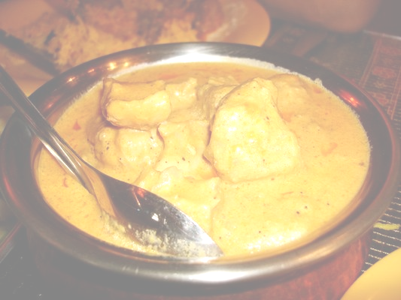
Ingredients
1 clove
1 clove of garlic
1 black peppercorn
1 cardamom pod
1x10ml spoon oil
100g chicken meat
1 small onion
Sliced peppers
½ green chilli
½ teaspoon turmeric
½ teaspoon ground cumin
½ teaspoon coriander spice
½ teaspoon chilli powder
3x15ml spoons plain yogurt
¼ tin coconut cream
pinch black pepper
1x15ml spoon coriander

Equipment
Chopping boards, knives, frying pan, fish slice, measuring spoons, garlic press, spoon.

Method
1. Prepare the garlic, chilli and onion, peppers:
- peel and crush the garlic;
- de-seed and chop the chilli;
- chop the onion.
- On a different chopping board, using a fresh knife, cut the chicken into cubes.
3. Fry the clove, peppercorn and cardamom in the oil until they sizzle.
4. Stir-in the garlic and chilli.
5. Add the chicken, peppers and onion, cover and slowly cook for about 10 minutes.
6. Mix the tumeric, coriander, chilli powder, pepper and cumin into the yogurt.
7. Increase the heat and stir-in the yogurt / coconut mix to the frying pan.
8. Allow to cook for a further 10 minutes.
9. Chop the coriander and stir into the korma.

Skills
Using the hob | Vegetable preparation | Frying

Research

Use the curry recipe cards, restaurant menus or cookbooks to investigate ingredients that you could use in the design of your own curry.

Suggest 3 combinations of ingredients for curries. Give reasons for your answers.  1  2  3 | Name 3 types of beans or pulses that could be added.  1  2  3
What could you serve with this dish? | What would be your top tips for preparing hot, spicy foods?
Suggest 4 different vegetables that could be used in a curry dish.  1  2  3  4 | Name 3 alternatives to lamb that could be successfully used in this recipe.
List 4 liquids that can be added to curry to reduce the hot flavour.  1  2  3  4 | Suggest three ways you could reduce the fat content of the curry.  1  2  3

Design your own Curry

Plan of Making for Curry
Design your own curry recipe. Plan how you are going to make it. You can use a recipe to help you but you need to include any changes on your plan (KEEP IT SIMPLE).

Ingredients | Equipment
Method

Assessment for Learning. Working towards…  □ Level 4 – I have writte step-by-step plans and selected appropriate equipment.  □ Level 5 - written detailed plans, changing them where appropriate.  □ Working towards Level 6 – I have been creative in my use of ingredients. I have written a detailed plan that outlines alternative methods/ingredients. |  | Level for  this work
Evaluation of your Curry Recipe

Sensory Attribute

1. Tick the appropriate box on the hedonic scale for your product.

Hedonic scale | Like a lot | Like a little | Neutral | Dislike a little | Dislike a lot

2. What did you like about your product? (Be specific about taste, texture and appearance.)

3. What did you dislike about your product? (Be specific about taste, texture and appearance.)

4. What did other people think of your product?

5. How could you improve your curry? (Be specific about the changes to cooking methods or ingredients.)

Assessment for Learning
□ Working towards Level 4 – I have written an evaluation and included strengths, weaknesses and suggestions for improvement.
□ Working towards Level 5 – I have written a detailed evaluation, including strengths, weaknesses and clear suggestions for improvement (eg. suggest changes to ingredients and quantities or changes to cooking processes.).
□ Working towards Level 6 – I have written a detailed evaluation, taking into account what other people said, and have several very clear suggestions for improvement.
Mushroom Risotto
Y10 – Can you remember this one!
Risotto is a traditional Italian dish made with a suitable variety of rice such as arborio, carnaroli or vialone nano. It is one of the most common ways of cooking rice in Italy. When risotto is cooked, the rice is first cooked briefly in butter or olive oil until evenly coated and the rice starts to turn translucent, before stock is added, one ladle at a time.

Learning Objectives
In this activity you will
- demonstrate competence in cooking a rice based dish, using minimal pieces of equipment;
- prepare a range of vegetables, e.g. peeling, slicing, dicing;
- use the hob safely.

Keywords: stocks, absorption, gelatinisation.

Ingredients
150g chestnut mushrooms
1 onion
2 cloves garlic
1 x 15ml spoon olive oil
250g risotto rice
1 x 5ml spoon vegetable stock powder
1-1.5 litres water, boiling
1 x 15ml spoon parmesan, grated
1 x 10ml spoon thyme, chopped

Equipment
Chopping board, knife, garlic press, weighing scales, measuring spoons, frying pan, wooden spoon, kettle, measuring jug.

Method
- Prepare the vegetables:
- peel and chop the onion;
- slice the mushrooms;
- peel and crush the garlic.
2. Fry the onion and garlic in the oil until softened.
3. Add the mushrooms, and fry for another 2 minutes.
4. Stir in the rice.
5. Mix the stock powder with the water.
6. Add a little of the stock to the rice – a little at a time. Wait for the stock to be absorbed, stirring constantly.
7. Continue adding the stock until the rice cooks – this will take 20-25 minutes. The rice should be soft, but still retain a nutty bite.
8. Stir in the parmesan and thyme into the rice.

Top tips
- Try using different ingredients, such as chicken, prawns or Mediterranean vegetables.
- Use different herbs and spices e.g. basil, parsley or chilli

Skills
Using the hob | Bridge-hold | Claw-grip | Onion preparation

Research

Use the recipe cards and cookbooks to find out other ingredients you can add to risotto. You will then design your own risotto.

Name 3 different combinations of ingredients that could be added to risotto. Give reasons for your answers.  1  2  3 | List four different herbs that are used to add flavour in a risotto?
How could you make this a complete, balanced meal? (Consider the Eatwell Plate: vegetable and protein needs.) | What would be your top tips for making a risotto?

Internet Activity: Licence to Cook
- Complete Cooking Tutorial Three and the Assessment on the www.licencetocook.org.uk
Design your own Risotto

Plan of Making for Risotto
Design your own risotto recipe. Plan how you are going to make it. You can use a recipe to help you but you need to include any changes on your plan.

Assessment for Learning
Working towards…
□ Level 4 - write step-by-step plans and select appropriate equipment.
□ Level 5 - write detailed plans, changing them where appropriate.
□ Level 6 - Be creative. Detailed plans that outline alternative methods/ingredients.
Ingredients | Equipment
Method

Level for
this work

Sizzling Stir-fry

A stir-fry is an oriental dish traditionally made in a round-bottom pan called a wok using a high heat and a small amount of cooking oil. Dry seasonings are added including ginger and garlic, then at the first moment the seasonings can be smelled, meat is added. Once the meat is seared, vegetables along with liquid ingredients (for example premixed combinations of soy sauce, vinegar, oyster sauce, fish sauce, sugar, and cornstarch) are added. Before you design your own recipe, look up some good recipes ideas for the sauce.

Learning Objectives
In this activity you will:
- become more confident preparing and cooking more ambitious main dishes.
- prepare a range of ingredients, e.g. de-seeding chillies, grating fresh ginger.
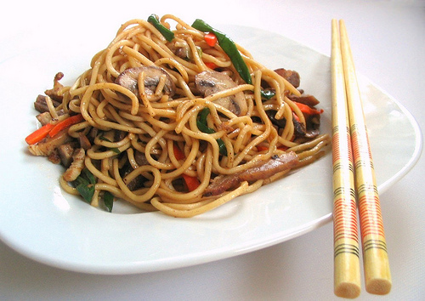

Ingredients
50g noodles
1/2 x chicken breast
½ red chilli
1 clove garlic
1cm fresh ginger
½ red onion
(Green Veg), pak choi / spinach / cabbage
1/2 yellow pepper
2 mushrooms
1x10ml spoon oil
1x10ml spoon soy sauce (reduced salt)

Equipment
Chopping boards, knives, garlic press, grater, wok or frying-pan, wooden spoon, saucepan, colander, measuring spoon, serving dish, weighing scales.

Method
1. Cook the noodles in boiling water. Check the packet for details.
2. While the noodles are cooking, remove any skin from the chicken and cut into strips. Place in the fridge, covered, until needed.
3. Prepare the vegetables with a fresh knife on a clean chopping board:
- peel and crush the garlic;
- de-seed and slice the chilli;
- peel and slice the ginger;
- slice the onion, pepper and mushrooms;
- shred the green vegetables.
4. Heat the oil in the wok or frying pan.
5. Add the onion, garlic, chilli and ginger. Allow to cook for 1 minute.
6. Add the chicken and stir-fry for 3-4 minutes. Check that the chicken is cooked.
7. Add the remaining vegetables and soy sauce and continue to cook for a further 2 minutes.
8. Drain the boiling hot water away from the noodles into a colander in the sink
9. Stir in the cooked noodles and cook for 2 minutes until hot.
10. Serve.
Top tips
- Use noodles that have already been cooked.
- Vary the vegetables – leeks, courgettes and carrots all work well.
- Go for tofu or more mushrooms instead of chicken for a vegetarian alternative.

Design your own Stir-fry

Plan of Making for Stir-fry
Design your own stir-fry recipe. Plan how you are going to make it. You can use a recipe to help you but you need to include any changes on your plan.

Assessment for Learning
Working towards…
- Level 4 - write step-by-step plans and select appropriate equipment.
- Level 5 - write detailed plans, changing them where appropriate.
- Level 6 – Be creative. Write a detailed plan that outline alternative ingredients/ methods.
Ingredients | Equipment
Method

Level for
this work

Evaluation of your Stir-fry Recipe

Sensory Attribute

1. Tick the appropriate box on the hedonic scale for your product.

Hedonic scale | Like a lot | Like a little | Neutral | Dislike a little | Dislike a lot

2. What did you like about your product?

3. What did you dislike about your product?

4. What did other people think of your product?

5. How could you improve your product?

Assessment for Learning
□ Working towards Level 4 – I have written an evaluation and included strengths, weaknesses and suggestions for improvement.
□ Working towards Level 5 – I have written a detailed evaluation, including strengths, weaknesses and clear suggestions for improvement (eg. suggest changes to ingredients and quantities or changes to cooking processes.)
□ Working towards Level 6 – I have written a detailed evaluation, taking into account what other people said, and have several very clear suggestions for improvement.
Quick V Lasagna

Lasagna (singular) or lasagne (plural) is an Italian dish made from layers of pasta sheets, cheese sauce and ragù. In America, lasagna sheets are sometimes rippled, but you are very unlikely to find rippled lasagna in Italy!
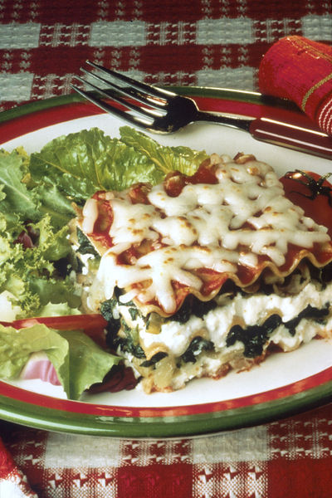

Ingredients
1 onion
1 garlic clove
1 carrot
2 celery sticks
100g green lentils
1 x 10ml spoon oil
400g canned chopped tomatoes
1 x 5ml spoon mixed herbs
1 x 15ml spoon tomato puree
200ml creme fraiche, reduced fat
25g parmesan, grated
50ml semi-skimmed milk
Black pepper
6 lasagne sheets

Equipment
Weighing scales, chopping board, knife, peeler, garlic press, saucepan, wooden spoon, measuring spoons, measuring jug, metal spoon, ovenproof dish or foil trays.

Method
1. Preheat the oven to 190oC or gas mark 5.
2. Prepare the vegetables:
- peel and chop the onion;
- peel and crush the garlic;
- peel and slice the carrot;
- slice the celery.
3. Fry the onion, garlic, carrot and celery in the oil until soft - about 4 minutes.
4. Add the lentils, tomatoes, herbs and tomato puree.
5. Pour in some water, just enough to cover the mixture, bring to the boil and then allow to simmer for 15 minutes with the lid on.
6. Blend the creme fraiche, half the grated cheese, milk and pepper together.
7. In an ovenproof dish or foil tray, spread some lentil mixture in the bottom, cover with lasagne sheets and a little creme fraiche sauce. Repeat this, finishing with the sauce on top.
8. Sprinkle the remaining grated cheese on top and bake for 20 minutes.

Top tips
- Experiment with different herbs, for example fresh basil or oregano for different flavour sensations!
- Try using different vegetables such as courgettes, peppers or aubergine.

Skills
Using the hob/oven | Onion preparation | Bridge hold / Claw grip | Assembling/layering

Design Brief – Design a healthy meal
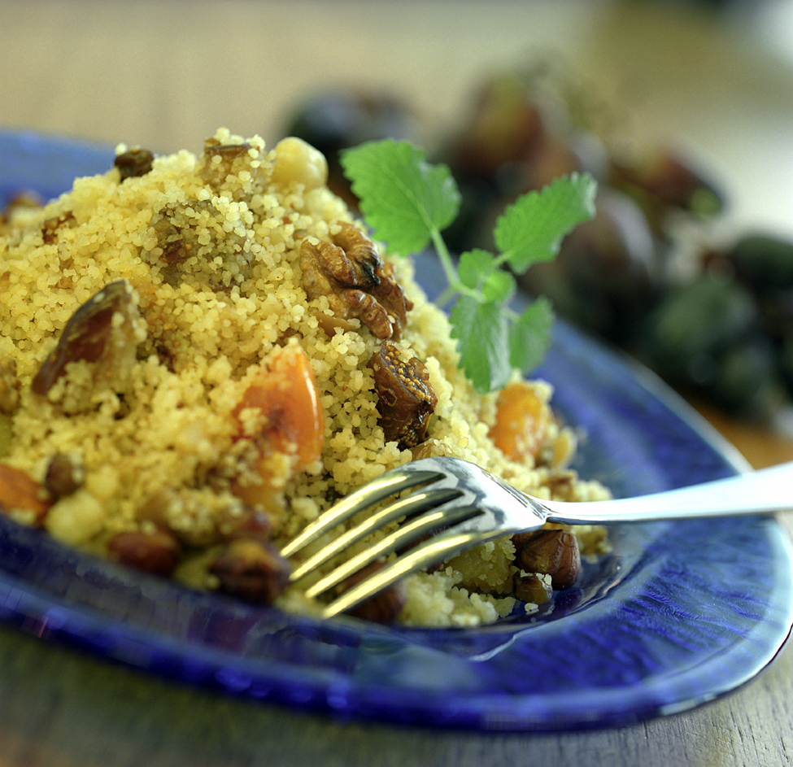
Learning Objectives
By the end of this task you should be able to:
- demonstrate confidence and competence cooking a main meal dish;
- manage your time effectively;
- prepare a range of vegetables, e.g. peeling, slicing, dicing;
- make a meat or alternative base;
- use the hob and/or oven safely.

Design Brief
Design a healthy meal for one person suitable to be served for lunch or dinner. (We will be inviting the school chef to the lesson to choose a winning dish which could be served for lunch as a school dinner.)

The meal should be:
- served hot (or part of it must be hot)
- be healthy (fit within the Eatwell plate. High in carbohydrates and vegetables, low in fat and salt.)
- have a combination of flavours
- have an attractive appearance
- have an interesting flavour that appeals to a wide range of tastes
- can be made within 60 minutes including washing up
- not cost more than £5 to serve one person.

Brainstorm of Ideas

Brainstorm of ideas and ingredients that you could make for your main course meal.

Disassembly Bought Ready Meals
Get one from your freezer and look at the ingredients, cook it then taste it!!

Product Name: ______________________________________________

Description: _________________________________________________


Cost | Weight (in grams)
Target Group(s)  Who is the product designed for? Eg. Children, teenagers, adults, families, singles, working adults, vegetarians, people on a special diet, religious groups? | Storage and Preparation  How is the product stored and prepared?
Ingredients

Appearance - consider the different parts to the product, the colour, shape, quality.

Summary of Sensory Analysis How would you describe the taste of the product? What are the strengths and weaknesses of the product?

Nutritional Analysis (per 100g)
Drawing
Calories
Carbohydrate
Protein
Fat
Fibre
Salt

Homework - Questionnaire

Aim: Find out what sort of meals people like In your home.
Method: Survey your family to find out what sort of meals, flavours and vegetables people like to eat.

Present your results here as graphs.

Extension: Use Excel to present your graphs.

Conclusion:

Main Meal Design Ideas

Design two different ideas for a main meal. Remember that you should consider the survey results.
Assessment for Learning
Working towards Level 4 - draw and label sketches.
Working towards Level 5 - draw and label quality coloured sketches.
Working toward Level 6 - present detailed drawings that are labelled and colour rendered.

…………………………………………………………………………………………………………………………………
Main Meal Manufacturing Specification

Keyword: Specification.

A Manufacturing Specification is a very detailed recipe sheet that explains to factory workers how to make the recipe. This final task requires you to apply your knowledge on food preparation and food hygiene and safety to writing a Manufacturing Specification for your main meal.
Assessment for Learning
Working towards Level 4 - produce step-by-step plans and select tools and equipment.
Working towards Level 5 - write detailed plans/ check your work as it develops.
Working towards Level 6c – Creative. Detailed plans that outline alternative methods. Progress checks.

Start
Wash hands, wear and apron, tie your hair back. Collect ingredients and equipment.
Check equipment is clean and food is within date.
Crossword Puzzle

 |  |  |  |  |  |  |  |  |  |  | 1
 |  |  |  |  |  |  |  |  | 2 |  |  |  |  |  |  | 3
 |  |  |  |  |  |  |  |  |  |  |  |  |  | 4
 |  |  |  |  |  |  | 5
 |  |  |  |  |  |  |  | 6 |  |  | 7
 |  |  | 8
 |  | 9
 |  |  |  |  |  |  |  |  |  |  |  |  | 10
 | 11
12
 | 13

ACROSS | DOWN
1 We should eat this high protein food at least twice a week.  5 A stewed vegetable dish from France.  9 These are a great source of fibre, vitamins and minerals.  11 One of the 4C’s. Temperature control to slow bacterial growth in food.  12 Passing bacteria from raw food to cooked food or raw meat to other foods.  13 Eating too much of this ingredient will give you high blood pressure. | 1 A healthy option high fibre snack. Better than crisps or biscuits.  2 Sausages, cheese, butter, cakes and biscuits are all high in ______ .  3 The thickening of starch when heated with water.  4 Protein foods that can easily give you food poisoning.  6 Fruit, vegetable and wholegrain cereals are high in this. Important for digestion.  7 A tasty Italian dish made with rice and flavoured with stock and vegetables.  8 The name of a sensory test used to evaluate a food product.  10 Too much food high in this ingredient can lead to diabetes and tooth decay.

