KS3/KS4 Physical activity
It is important while being at home that we try and maintain or build our fitness. this is good for both mind and body and can include the whole family. There are lots of online fitness videos to follow. Please follow the links below. Try to do at least 30mins of moderate (increases the breathing so it if fast but you can just about hold a conversation) physical activity each day.

To access links either click the link should take you to the webpage or copy and past the website address into the search bar to take you to the website. All of these can be used on phones, tablets, computers and some TV’s with internet and games consoles with internet access.
Fitness and health
- The Body Coach TV (free) - https://www.youtube.com/channel/UCAxW1XT0iEJo0TYlRfn6rYQ
There are lots of different work outs to meet different ages and fitness levels.

- Nike training app (free) - https://www.nike.com/ntc-app
Personalise your training for all ages and ability to get yourself in shape, tone up or just stay active.

- Sworkit app (free) - https://sworkit.com/
Sworkit can help. A fitness apps for iPhone, Android, or web users. Workout plans are designed to help you reach your fitness goals faster and simpler.

- Game console forfeit
We all know how many kids will be glued to their games console. How about adding some fitness? Create a forefeet board for some of their favourite games eg fortnight. Eg every time they die / lose on a game they must complete 10 press-ups, every time they level up they must jog on the spot for 10 mins, 10 burpees, 10 sit ups ect. Be creative. Here are some links to help with exercises to include.

https://www.self.com/gallery/bodyweight-exercises-you-can-do-at-home

https://www.acefitness.org/education-and-resources/lifestyle/blog/6593/top-25-at-home-exercises/

Movement Skills
- HOT LAVA
Cutting out squares of non-skid shelf matting or place non slip objects on the floor. I spread the matting around on the floor, and the players have to hop from “stone” to “stone” without falling into the hot lava. Make the gaps bigger or smaller depending on ability.
- “SNOWBALL” FIGHT

Ball up some socks and throw them at one another! Don’t get hit or you turn into a snow statue

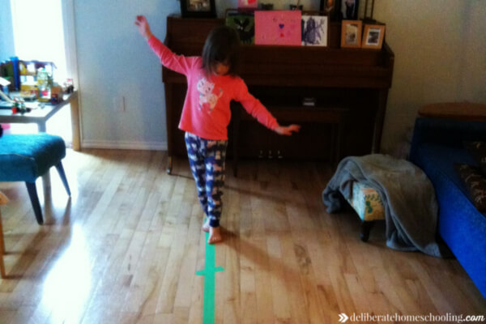
BALANCE BEAM
This is an easy one to set up. Stick a long piece of tape to the floor and encourage your children to walk across the beam without falling off. You can make it more challenging by having them hop from one balance beam to another.

BEAN BAG TOSS
Set up a target (cardboard box, washing basket, target on the floor) and have your children toss bean bags (or rolled up socks) into it. Each worth a different point value), use a box with cuts holes in it. Compete for the highest score.
- Obstacle courses
Use household items to create an obstacle course in your house. Use a timer on your phone to race over or under the obstacles. Ensure clear rules are set and everyone knows the route.

Games
- Football (any ball can be used)
Use objects to create an obstacle course to dribble around. Encourage using different part of their feet to move the balls without touching any objects. Set up a time challenge where every object touched adds 5seconds to their time.
- Sock Pong
Roll sock into a ball. Mark out two goals with tape or objects as posts e.g. jumpers. The goal can be altered in size to make it harder or easier. Use feet or hands to slide the socks along the floor to try and beet the other player. if outdoors a ball can be used to played the same game.

Have fun work out together and try and keep to a daily od every other day rota of exercise.

