LOOKING & SEEING
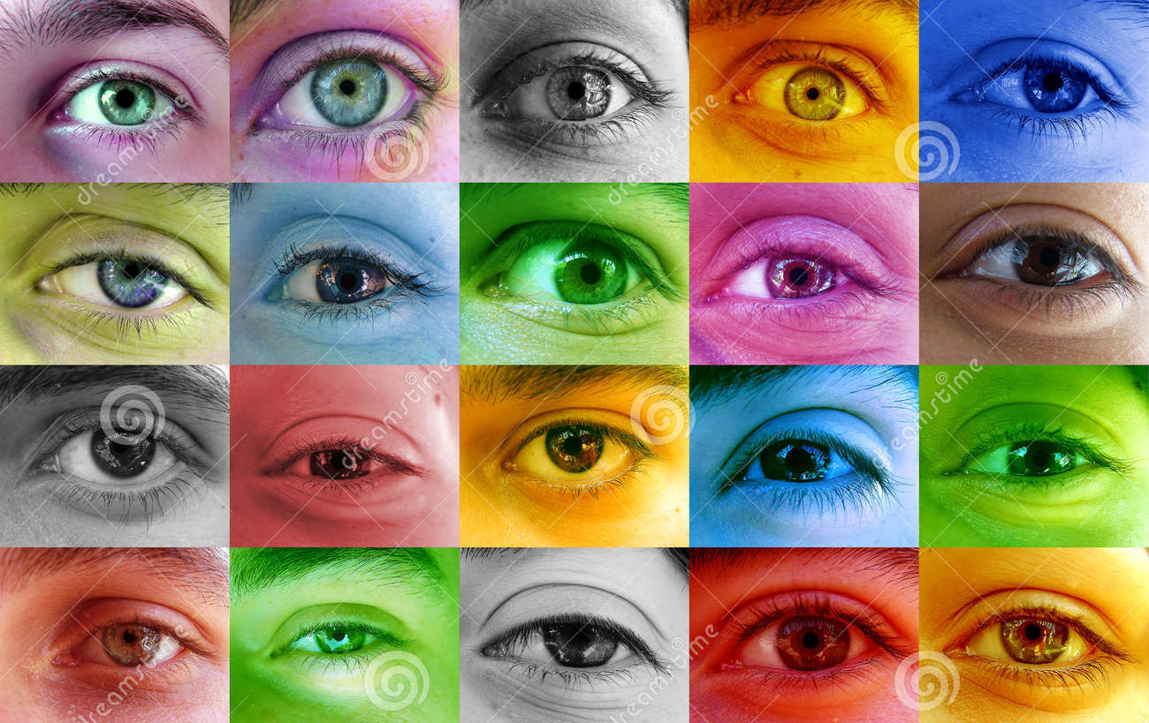

Making art is about looking & seeing and then through a creative process making your own artistic response to the world around you. The more you ‘look’ the more you will see your art skills improve so it is important to take time to enjoy simply looking at what other people are creating; looking deeper will help you make better art.

A great place to start learning to ‘look’ is Google Arts & Culture. It is easy to use, click the link and have fun discovering hundreds of amazing ways artists throughout time have reinterpreted our world!
https://artsandculture.google.com/

Enjoy!

