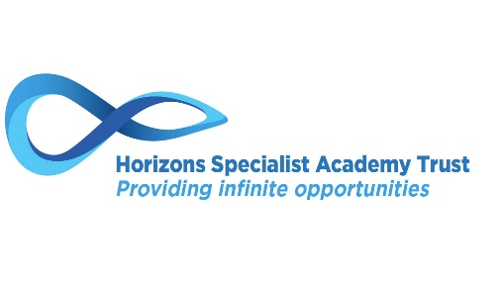
PUPIL PREMIUM – PLANNED SPEND AND PREDICTED IMPACT
2020/2021

HOLLIS ACADEMY

The Pupil Premium is designed to ensure that funding to tackle disadvantaged students reaches those who need it most and has a positive impact upon narrowing the outcome gaps. The funding is allocated to Local Authorities and schools with students from Early Years to Year 11 who are looked after, have parents currently in the Armed Forces or are eligible for free school meals (FSM), including those eligible for FSM at any point in their childhood.

The Government does not prescribe how pupil premium should be spent, believing that schools are in the best position to decide - on the basis of available evidence of what works well elsewhere - the appropriate strategies in their particular circumstances. This report highlights how the funding will be used during the academic year 2020-2021.

The proportion of disadvantaged students, those supported by pupil premium at Hollis Academy, is much higher than average, with 57 students (77.03%) of the cohort classed as disadvantaged.

PROJECT | PLANNED SPEND | PREDICTED IMPACT
Quality of Education
AP Programme and Vocational Provision | £19,500 | - All PP students making good progress in all subjects studied throughout the AP programme and to ensure they get accreditation in English and Maths.
1:1 Weekly Literacy Intervention for all Looked After Children and all Pupil Premium Children identified as being significantly behind target in English. | £6,000 | - To support identified students who are struggling with the curriculum and need 1:1 support. (More important due to the issues of missed learning during Covid)  - Students in Key Stage 3 to re-engage in the curriculum after a long absence from school.  - Key Stage 4 students to complete Entry Level qualifications and in some instances Functional Skills.
1:1 Weekly Maths Intervention for all Looked After Children and all Pupil Premium Children identified as being significantly behind targets in Maths. | £6,000 | As above
Educational Trips | £3,000 | - Open Awards introduced enabling students to go on more visits throughout Key Stage 4.  - Key Stage 3 completing Vocational Education opportunities outside of the classroom. Educational visits are able to continue for all students.
Behaviour and Attitudes
Enrichment | £1,000 | - To provide a better range of activities to support all learners.  - The introduction of an increased number of offsite activities for enrichment that will encourage better behaviour around school.
Incentives for improvement in attendance and behaviour | £1,400 | - Improve attendance within the school with end of term rewards for higher attending/improving students.  - Opportunities to support students who are struggling with behaviour by providing interventions.
Personal Development
Alliance | £12,810 | - To provide a counselling service to support students and their families.  - Last year it was important to support our students but due to the pandemic, the support will be needed more than ever. We know that we have students and parents already accessing the service during this period.
PSA / Safeguarding Lead support | £9,000 | - To continue to reduce the PA figures.  - All identified staff completed DSL training. Staff all using CPOMs and Behaviour Watch. (Due to Covid the recording of welfare calls on Cpoms has been vital for the school to support parents)  - Hollis DSL’s to continue to track Safeguarding cases and review them monthly with the Trust Lead and or Deputy Lead for Safeguarding.  - To ensure the Academy has a clearer understanding of the support needed for our most vulnerable and that actions can be in place.  - All LAC files are up to date.
Breakfast Club | £500 | - To ensure that students have eaten before they start learning.  - To provide a welcoming and calm start to the morning.

Total Pupil Premium Budget: | £59,210
Total Spend to date: | £59,210

